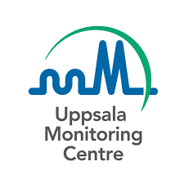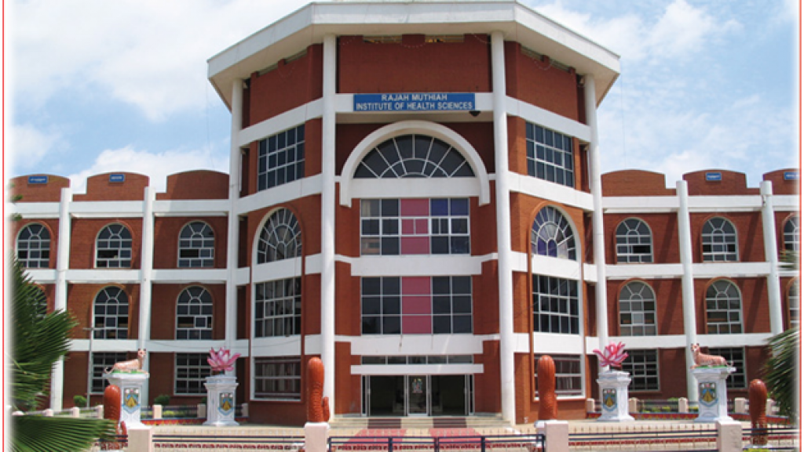

**PHARMACOVIGILANCE**

**A step towards patient's safety**

(Pharmacovigilance week 17-23 Sep 2021)

**ORGANISED BY**

DEPARTMENT OF PHARMACOLOGY

along with

MEDICAL EDUCATIONAL UNIT

RAJAH MUTHIAH MEDICAL COLLEGE

ANNAMALAI NAGAR,CHIDAMBARAM

